Executive Summary:
What is the status of achieving what was presented in the plan in NJCCN Policy Analysis: Improving Access to Care for New Jersey 2019?
Note: all the following bullet points have likely changed since COVID-19.
- Primary care access continues to be inadequate (See page 3)
- Fifteen of the 21 counties have a deficit of mental health providers which will impact the mental health of the population. (See page 4)
- In four of the 21 counties the uninsured populations are above 9%. (See page 5)
- Health outcomes and health factors continue to be poor in counties with a lower per capita income. Some have improved and some have worsened. (See page 6)
- Over 75% of Nurse Practitioners (NP) are educated in a primary care specialty and can fill the primary care shortage. (See page 7)
- Outmigration of NPs is a serious concern with NPs who are licensed in NJ working in New York (NY). (See page 7)
What milestones or achievements may have occurred in regard to the plan?
- In 2019, during the 218th Legislature, Senate bill “Consumer Access to Health Care Act” was heard in the Health, Human Services and Senior Citizens Committee. NJCCN provided testimony on APN practice. This was passed and moved out of committee.
- In the current 219th Legislature, A1760 “Consumer Access to Health Care Act” eliminates requirement of joint protocol with physician for advanced practice nurses to prescribe medication.
- Executive Order 112 by Governor Murphy on April 1, 2020 removed the barriers to practice for APNs. This continues due to COVID-19.
Challenges
- Current data does not reflect how the current state of COVID-19 has impacted these data.
- Current focus is on improving health outcomes related to COVID-19 thereby limiting ability to communicate with key stakeholders. However, removing the joint protocol temporarily is likely to improve access to care during the pandemic.
How may have COVID-19 influenced the timeline?
- May assist expediting removal of joint protocol after COVID-19 decreases in the state as there will be a greater need for primary care providers that currently cannot be met by physicians alone.
Update on Improving Access to Care in NJ-2021
In 2019 the New Jersey Collaborating Center for Nursing (NJCCN) completed a Policy Analysis: Improving Access to Care for New Jersey (NJ). The report supported the need to eliminate barriers for APN practice by removing the joint protocol requirement. These barriers impact access, cost, and quality of care. In 2021 we reviewed the current gaps in healthcare for NJ residents as an update to our original report.
Twenty-three states and the District of Columbia and several territories have full practice authority as of 2021. Since our last report, we have seen an increase of one state to receive full practice authority, however improvements have been made in other states to improve access to care by removing barriers to practice. Especially during this pandemic NPs can help improve access to care by allowing NPs to work to the full extent of their licensure and certification. According to the American Association of Nurse Practitioners (2021) 89% of the 191,000 NPs in the United States are credentialed in primary care and more than 75% of these are actively practicing in primary care which is reflective in our NJ workforce data as well.

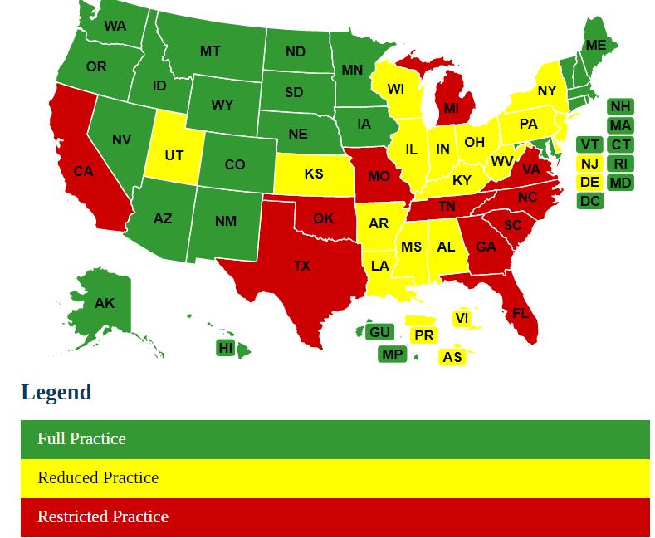
Source: American Association of Nurse Practitioner (2021) Map of practice levels. https://www.aanp.org/advocacy/state/state-practice-environment

Primary Care Availability in New Jersey
The United States average for the ratio of population to primary care physicians is a higher ratio (1320:1) as compared to NJ (1179:1). NJ is below the national average overall however there is a variability by county 820:1 to 2720:1. When breaking this down by county the following can be found. For purposes of this chart, we have used the US average to determine which counties do not meet the national benchmark. Ten counties or 48% of the 21 counties do not have enough primary care providers. This gap continues to be an issue for the state and could be addressed by eliminating APN barriers to practice.
The growing aging population in New Jersey is also of concern. Eleven counties or 52% of the 21 counties have a higher percentage of senior citizens, persons 65 years of age and older, when compared to the national percentage of 16.5%. Of particular concern are the two counties in New Jersey with the greatest number of senior citizens, Cape May with 27.3% seniors and Ocean with 22.8% seniors are also counties that do not have enough primary care providers.
County | # Primary Care Physicians | Primary Care Physicians Rate | Primary Care Physicians Ratio | Comparison to last report
NJ | 7553 | 85 | 1179:1
Atlantic | 220 | 83 | 1206:1 | I
Bergen | 1106 | 118 | 847:1
Burlington | 378 | 85 | 1178:1 | I
Camden | 522 | 103 | 971:1
Cape May | 56 | 61 | 1653:1 | X
Cumberland | 63 | 42 | 2396:1 | X
Essex | 677 | 85 | 1181:1 | I
Gloucester | 158 | 54 | 1844:1 | X
Hudson | 357 | 53 | 1894:1 | X
Hunterdon | 152 | 122 | 820:1
Mercer | 370 | 100 | 999:1
Middlesex | 777 | 94 | 1068:1
Monmouth | 741 | 119 | 839:1
Morris | 513 | 104 | 963:1
Ocean | 258 | 43 | 2332:1 | X
Passaic | 281 | 56 | 1791:1 | X
Salem | 23 | 37 | 2722:1 | X
Somerset | 387 | 117 | 856:1
Sussex | 71 | 50 | 1983:1 | X
Union | 380 | 68 | 1469:1 | X
Warren | 63 | 60 | 1679:1 | X
I=improved since 2019 X=the same or greater deficit. Source: County Health Rankings 2021. https://www.countyhealthrankings.org/sites/default/files/media/document/CHR2021_NJ.pdf
Mental Health Providers in NJ
Prior to COVID-19 mental health providers were an issue in the state and nation. In the US there are 380 patients to 1 provider. In NJ, the number of patients to provider is 415 to 1 with a range of 130:1 to 1450:1. The data below is compared to the US ratio of 380:1 which is 15 out of 21 counties or 71% of the counties in NJ who have limited access to mental health providers. Again, this can be decreased by modernizing APN practice legislation.
 | Mental Health Providers | Provider Rate | Provider Ratio
New Jersey | 21393 | 241 | 415:1
Atlantic | 455 | 173 | 579:1
Bergen | 2413 | 259 | 386:1
Burlington | 3475 | 780 | 128:1
Camden | 1653 | 326 | 306:1
Cape May | 101 | 110 | 911:1
Cumberland | 154 | 103 | 971:1
Essex | 1788 | 224 | 447:1
Gloucester | 366 | 125 | 797:1
Hudson | 465 | 69 | 1446:1
Hunterdon | 311 | 250 | 400:1
Mercer | 1247 | 339 | 295:1
Middlesex | 1593 | 193 | 518:1
Monmouth | 1748 | 282 | 354:1
Morris | 1392 | 283 | 353:1
Ocean | 1009 | 166 | 602:1
Passaic | 640 | 128 | 784:1
Salem | 73 | 117 | 855:1
Somerset | 926 | 282 | 355:1
Sussex | 242 | 172 | 581:1
Union | 1109 | 199 | 502:1
Warren | 224 | 213 | 470:1

Source: County Health Ranking: (2021). https://www.countyhealthrankings.org/sites/default/files/media/document/CHR2021_NJ.pdf

Uninsured
The percentage of population under age 65 without health insurance is 10% in the US as compared to NJ which is at 9% pre-COVID-19. Four counties had an uninsured rate above 9%, however this continues to be too high. However, with COVID-19 we know that these numbers have increased exponentially due to closures of business and a reduced workforce. We also know that due to restrictions and concerns by the public, elective procedures were reduced, and healthcare was not a high priority. This will impact the healthcare system as COVID-19 decreases in the state with greater health risks not being addressed.

 | # Uninsured | % Uninsured
 | 642184 | 9
Atlantic | 20495 | 10
Bergen | 67613 | 9
Burlington | 19387 | 5
Camden | 34136 | 8
Cape May | 5316 | 8
Cumberland | 12682 | 11
Essex | 78002 | 12
Gloucester | 12636 | 5
Hudson | 75622 | 13
Hunterdon | 4072 | 4
Mercer | 27357 | 9
Middlesex | 53086 | 8
Monmouth | 34259 | 7
Morris | 21277 | 7
Ocean | 35474 | 7
Passaic | 56582 | 7
Salem | 3549 | 7
Somerset | 14992 | 7
Sussex | 6584 | 7
Union | 53035 | 7
Warren | 6028 | 7

Source: County Health Rankings (2021) https://www.countyhealthrankings.org/sites/default/files/media/document/CHR2021_NJ.pdf

Disparities across counties in NJ
Counties with lower incomes tend to experience lower health factors and poorer health outcomes. For example, Cumberland County has poor health outcomes and factors and the lowest per capita median income in the state. Boosting the supply of practitioners in lower income counties may improve the overall health of New Jersey residents. See chart below.
Health Outcomes is defined by length of life and quality of life.
Health Factors is defined as health behaviors, clinical care, social and economic factors, and physical environment.
Health Outcomes, Health Factors, and Per Capita Median Income by County
County | Health Outcomes* | Health Factors* | Per Capita Income (2019)
Morris | 1 | 1 | 115,527
Hunterdon | 2 | 2 | 115,379
Somerset | 3 | 3 | 113,611
Bergen | 4 | 4 | 101,144
Sussex | 7 | 6 | 94,520
Middlesex | 5 | 7 | 89,533
Monmouth | 6 | 5 | 99,733
Union | 8 | 13 | 80,198
Burlington | 13 | 8 | 87,416
Ocean | 10 | 12 | 70,909
Warren | 11 | 9 | 81,307
Hudson | 9 | 14 | 71,189
Passaic | 14 | 17 | 69,688
Mercer | 12 | 10 | 81,057
Gloucester | 15 | 11 | 87,283
Cape May | 16 | 15 | 67,074
Atlantic | 18 | 19 | 62,110
Essex | 17 | 18 | 61,510
Camden | 19 | 16 | 70,451
Salem | 20 | 20 | 66,842
Cumberland | 21 | 21 | 54,149
Yellow indicators worse than 2018 results reported; Green shows improvement
Sources:
U. S. Census Bureau (2019) https://www.census.gov/quickfacts/fact/table/
*County Health Rankings (2021) uses various data sources to obtain these rankings. https://www.countyhealthrankings.org/sites/default/files/media/document/CHR2021_NJ.pdf

Workforce of Nurse Practitioners
There is increased growth in the APNs in New Jersey based on the educational capacity data from our latest report (NJCCN, 2021). There are 10,718 APNs in NJ (NJCCN, 2021) of which 8,614 APNs identified as Nurse Practitioners (NPs). Specialties identified can be found in the table below.
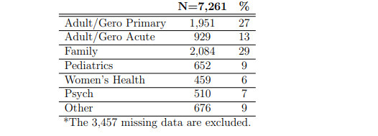
Source: NJCCN (2021). https://www.njccn.org/wp-content/uploads/2021/03/Data-Report-2021.pdf
Outmigration of NPs to New York and Pennsylvania
The following have active licenses outside of NJ. Of those that hold licensure in New York and Pennsylvania, NJ continues to be at risk if NY and Pennsylvania (PA) change their regulations to remove barriers to APN practice. New York has made changes to their laws. NPs are not required to have a collaborating agreement with a physician if they have met the 3600-hour experience requirement. This provides more flexibility for NPs in NY and therefore the risk of losing NPs to NY is a serious concern. This has changed since our last report. Currently COVID-19 has removed barriers to NP practice in all 3 states. The following table lists the number of NPs who have active licenses in other states.
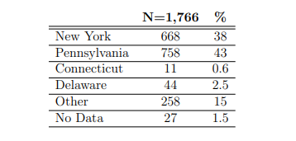
Source: NJCCN (2021). https://www.njccn.org/wp-content/uploads/2021/03/Data-Report-2021.pdf

References
American Association of Nurse Practitioner (2021) Map of practice levels. https://www.aanp.org/advocacy/state/state-practice-environment
New Jersey Collaborating Center for Nursing (2021). Nursing data and analysis. Newark, NJ: NJCCN. https://www.njccn.org/wp-content/uploads/2021/03/Data-Report-2021.pdf
NYSED (2019) Practice information. http://www.op.nysed.gov/prof/nurse/nursepracticefaq.htm#
University of Wisconsin Population Health Institute. County health rankings for New Jersey (2021). https://www.countyhealthrankings.org/sites/default/files/media/document/CHR2021_NJ.pdf

US Census Bureau (2019) Quick facts New Jersey. https://www.census.gov/quickfacts/fact/table/NJ/SBO001212

Prepared by:
Edna Cadmus PhD, RN, NEA-BC, FAAN --Executive Director, NJCCN Contact Information: ednacadm@sn.rutgers.edu 973-353-1428 or cell: 201-294-7369
Pamela de Cordova PhD, RN-BC--Nurse Scientist, NJCCN
Susan Weaver, PhD, RN, CRNI, NEA-BC—Nurse Scientist, NJCCN

