2015 Building a Culture of Health through Innovation Grant Application

Sponsored by: New Jersey Collaborating Center for Nursing (NJCCN), New Jersey Nursing Initiative (NJNI), and New Jersey Health Initiative (NJHI)

Building on the 2015 NJCCN Summit, NJ Grassroots Nurses: Building a Culture of Health through Innovation sponsored in partnership with NJAC, NJNI and NJHI, nurses can submit proposals for an Innovation Grant. The 2015 Summit encouraged nurses to be innovative, to take risks and try new things. Thus the purpose of this one-year grant of $5,000 is to enable nurses to use the problem solving and innovative skills they learned at the Summit to impact their communities. The Robert Wood Johnson Foundation (RWJF) diagram is provided below to help you categorize how your project fits into the action areas of building a culture of health.
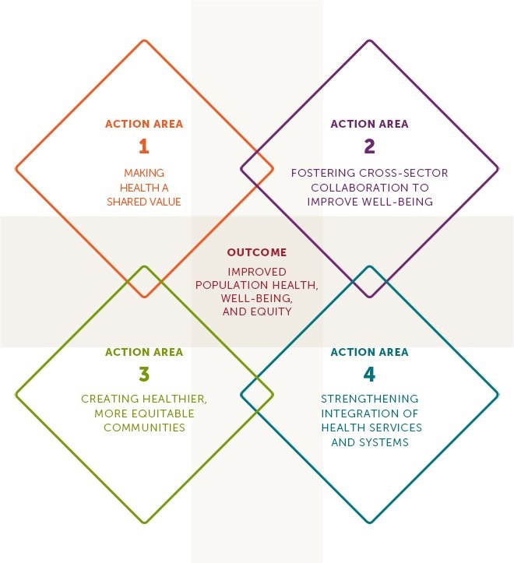
To start, you need to identify a group across sectors to work with you on this project. This group should include nurses (may include other disciplines) from at least two settings, for example, hospital and public health. You also need to include community members, for example, the mayor of your town or a community group.

Innovative Grant Proposal must include:

- A succinct proposal (not to exceed 5 double spaced pages, Times New Roman or Arial Font size 12) outlining the project to include:
- Abstract
- Describe the problem you plan to address and how it fits into building a culture of health
- Define the team to include nurses across at least 2 setting (may include other disciplines) and community members
- Identify purpose/goals/measureable objectives for your project
- Explain the solution(s) you plan to implement along with a proposed timeline.
- What evidence/data supports your problem?
- How will you implement your solution?
- What are your measures of success? How will you know you are successful? What metrics will you measure?
- What are the challenges that you anticipate while implementing your plan?
- What resources will you need to implement your solutions (people, time, funds, technology, etc.)?
- Complete a budget worksheet outlining how the $5,000 grant money will be utilized. Budget will be reviewed and modified based on the committee review of the submitted budget document.
- Submit a one-page overview about each member of the project team to include their work setting and what they will contribute to the project
- Include two letters of support for this project, and if applicable, an executive sponsor letter of support.

The 2015 Building a Culture of Health through Innovation Grant should be submitted to
ednacadm@sn.rutgers.edu and is due by February 1, 2016.

Up to 3 grants will be awarded. The grants will be released on March 31st, 2016.

Budget Template
Please complete the following budget template. Costs that are not allowable on this grant include grantee salaries, fringe benefits, and indirect costs.

Budget Category | Total Requested | Rationale/Justification
Consultants/Experts
Travel
Clerical Support
Statistical Support
Supplies
Printing
Meeting Expenses
Technology
Other

